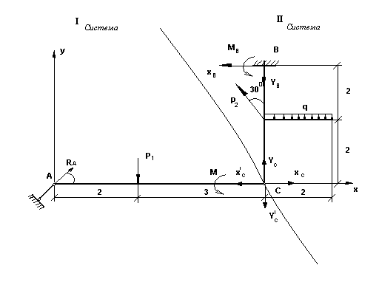
Задание С3
Дано: Решение:
P₁=13,0 kH I система:
P₂=9,0 kH Σ_{x}=0;
M=30,0 kH*M R_{A}*cos30º – X^{I}_{C}=0;
q=3,0 kH/M Σ_{y}=0;
R_{A}*cos60º – P₁ – Y^{I}_{C}=0;
M_{B} - ? ΣM_{C}=0;
M+P₁*3-2,5*R_{A}=0;
$$R_{A}=\frac{M+P_{1}∗3}{2,5}=\frac{\text{30}+\text{13}∗3}{2,5}=\text{27},6$$
$X_{c}^{I}=R_{A}\text{*cos}{\text{30}}^{0}=\text{27},6∗\frac{\sqrt{3}}{2}=\text{13},8\sqrt{3}$;
$Y_{C}^{I}=R_{A}\text{*cos}{\text{60}}^{0}−P_{1}=\text{27},6∗\frac{1}{2}−\text{13}=0,8$;
Проверка:
ΣM_{A}=0;
$−P_{1}∗2−Y_{C}^{I}∗5+M=0$;
$−\text{13}∗2−0,8∗5+\text{30}=0$;
-26 - 4+30=0;
0=0; верно.

II система:
Σ_{x}=0;
$X_{C}−P_{2}\text{*cos}{\text{60}}^{0}−X_{B}=0$;
$X_{B}=X_{C}−P_{2}\text{*cos}{\text{60}}^{0}=\text{13},8\sqrt{3}−9∗0,5=\text{13},8\sqrt{3}−4,5$;
Σ_{y}=0;
$Y_{C}−Q+P_{2}\text{*cos}{\text{30}}^{0}−Y_{B}=0$;
$\text{0,8-6}+\text{9*}\frac{\sqrt{3}}{2}=Y_{B}$;
$Y_{B}=4,5\sqrt{3}−5,2$;
ΣM_{B}=0;
$X_{C}∗4−Q∗1−M_{B}−P_{2}\text{*cos}{\text{60}}^{0}∗2=0$;
$\text{13},8\sqrt{3}∗4−6−9∗0,5∗2=M_{B}$;
$M_{B}=\text{55},2\sqrt{3}−6−9$;
$M_{B}=\text{55},2\sqrt{3}−\text{15}$;
Проверка:
ΣM_{C}=0;
$X_{B}∗4−M_{B}−Q∗1+P_{2}\text{*cos}{\text{60}}^{0}∗2=0$;
$(\text{13},8\sqrt{3}−4,5)∗4−\text{55},2\sqrt{3}+\text{15}−6+9∗0,5∗2=0$;
$\text{55},2\sqrt{3}−\text{18}−\text{55},2\sqrt{3}+\text{15}−6+9+0$;
0=0; верно.

