Вариант 3 Д1
Дано: $α={\text{30}}^{0};$ $V_{A}=3\text{.}5мс;$ $f≠0;$ $l=8м;$ $d=\text{10}м;$ $β={\text{60}}^{0}\text{.}$ Определить $V_{В}$ и $τ$.
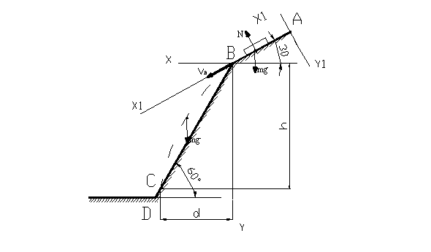
Решение:
m$\vec{a}$=$\vec{F}$
1) m$\vec{a}$=$\vec{Q}+\vec{R}+\vec{P}+\vec{N}$
OZ: m$a_{z}$= -Q+R+Psin$\text{60}°$
$a_{z}$=$\frac{dυ}{\text{dt}}$; P=mg; R=0,5$υ^{2}$;
m$\frac{dυ}{\text{dt}}$= -Q+0,5$υ^{2}$+mg sin$\text{60}°$ | :m
$\frac{dυ}{\text{dt}}$= -$\frac{Q}{m}$+$\frac{\text{0,5 }υ^{2}}{m}$+g sin$\text{60}°$
$\frac{dυ⋅\text{dl}}{\text{dt}⋅\text{dl}}$=$\frac{dυ⋅υ}{\text{dl}}$=$\frac{\text{0,5 }}{m}$$\left(−\frac{Q}{0,5}+\frac{\text{mg}\text{sin}\text{60}°}{0,5}+υ^{2}\right)$
$$b^{2}=−\frac{Q}{0,5}+\frac{\text{mg}\text{sin}\text{60}°}{0,5}$$
$b^{2}=−\frac{Q}{0,5}+\frac{\text{mg}\text{sin}\text{60}°}{0,5}$=$−\frac{\text{16}}{0,5}+\frac{8⋅9,\text{81}⋅0,\text{866}}{0,5}≈$104
$\frac{dυ⋅υ}{\text{dl}}$=$\frac{\text{0,5 }}{m}$$\left(b^{2}+υ^{2}\right)$
$\int_{υ}{}\frac{dυ⋅υ}{\left(b^{2}+υ^{2}\right)}$=$\frac{\text{0,5 }}{m}\int_{l}{\text{dl}}$
$\frac{1}{2}\text{ln}(b^{2}+υ^{2})=l\frac{0\text{.}5}{m}+C$
н.у: $υ_{0}$=10 м/c; l=4;
С=$\frac{1}{2}\text{ln}(b^{2}+υ^{2})−\frac{l}{m}$=$\frac{1}{2}\text{ln}(\text{104}+{\text{10}}^{2})−\frac{4}{8}≈$2,16

$\left(b^{2}+υ^{2}\right)$=$e^{\frac{l}{m}+4,\text{32}}$
$υ=\sqrt{−b^{2}+e^{\frac{l}{m}+4}}$=$\sqrt{−\text{104}+e^{\frac{4}{8}+4,\text{32}}}≈$4 м/c
- m$\vec{a}$=${\vec{F}}_{\text{тр}}+{\vec{F}}_{x}+\vec{P}+\vec{N}$
OY: N=Pcos$\text{30}°$=$\text{mg}\text{cos}\text{30}°$
OX: m$a_{ч}$=$F_{x}−F_{\text{тр}}+P\text{sin}\text{60}°$=$F_{x}−\text{fN}+P\text{sin}\text{60}°$=$−6\text{sin}2t−\text{fmg}\text{cos}\text{30}\text{°+}\text{mg}\text{sin}\text{60}°$
$$a_{x}=\frac{{dυ}_{x}}{\text{dt}}$$
$\frac{\text{md}υ_{x}}{\text{dt}}$=$−6\text{sin}2t−\text{fmg}\text{cos}\text{30}\text{°+}\text{mg}\text{sin}\text{60}°$ | :m
$\frac{{dυ}_{x}}{\text{dt}}$=$\frac{−6\text{sin}2t}{m}−g(f\text{cos}\text{30}\text{°+}\text{sin}\text{60}°)$=$\frac{−6\text{sin}2t}{8}−9,\text{81}(0,2⋅0,\text{866}+0,\text{866})$=$−0,\text{75}\text{sin}2t−\text{10},2$
$\int_{υ_{x}}{{dυ}_{x}}$= -$\int_{t}{\text{0,75sin2t}+\text{10,2}}$
$υ_{x}$=0,375cos2$t^{2}$-10,2t+C
н.у: t=0; $υ_{x}$=4 м/с;
C${}_{1}$= 4-0,375=3,625
$υ_{x}$=0,375cos2$t^{2}$-10,2t+3,625

$υ_{x}=\frac{\text{dx}}{\text{dt}}$; $\frac{\text{dx}}{\text{dt}}$=0,375cos2t-10,2t+3,625
$\int_{x}{\text{dx}}$=$\int_{t}{\text{0,375cos2t -10,2t+3,625}}$
x=0,2sin2t-5,1$t^{2}$+3,625t+C${}_{2}$
н.у: $x_{0}$=0; $t_{0}$=0; => C${}_{2}$=0

Ответ: x=0,2sin2t-5,1$t^{2}$+3,625

